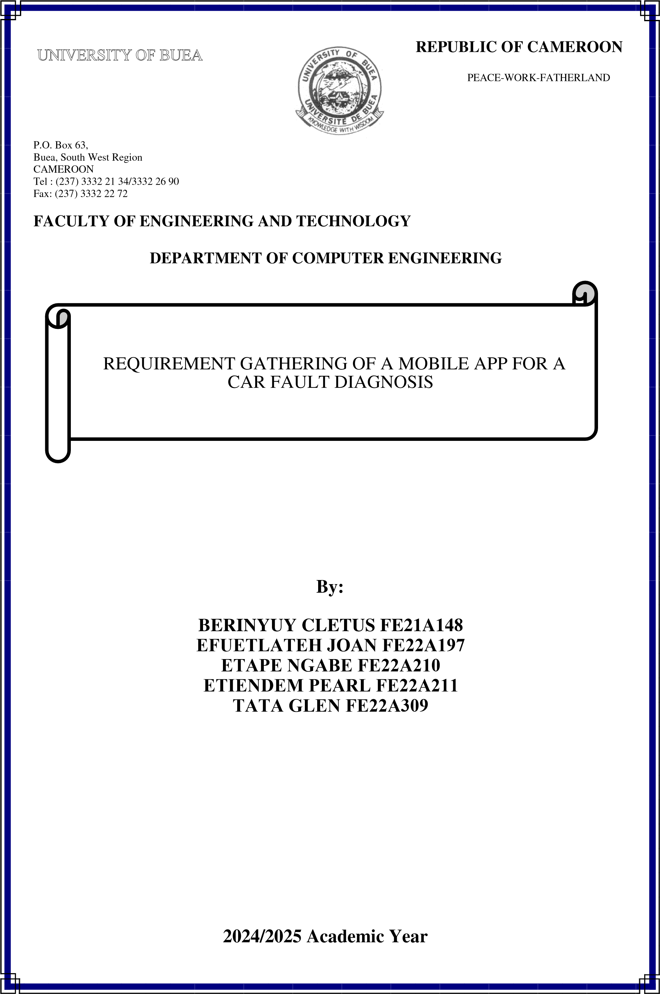

Contents

1. INTRODUCTION 3

2. STAKEHOLDERS 3

3. METHODS OF REQUIREMENT GATHERING 3

4. DATA GATHERING 4

4.1 Tools Used 4

4.2 Survey Findings 4

4.3 Interview Findings 9

5. DATA CLEANING 10

6. USER RELUCTANCE ASSESSMENT 10

7. CONCLUSION 11

# INTRODUCTION

The primary objective of this mobile app is to assist car owners in understanding the meaning of dashboard warning lights and identify engine-related issues through AI-powered sound analysis.

To develop a reliable and user-friendly mobile application for car fault diagnosis, it is essential to gather comprehensive requirements from both functional and non-functional perspectives. This section outlines the methods used for requirements collection and the categorized requirements identified.

# STAKEHOLDERS

The following stakeholders were identified as relevant to the success of the project:

* **Primary Users:** Car owners and drivers
* **Secondary Users:** Mechanics, technicians
* **Data Providers:** Automotive experts, car manufacturers
* **Project Team:** Developers and UI/UX designers
* **Academic Supervisor:** Lecturer evaluating the app

# METHODS OF REQUIREMENT GATHERING

To effectively collect user needs and expectations, the following methods were employed:

* **Interviews:**   
  We conducted informal interviews with mechanics and car owners. These conversations focused on common car problems, reactions to warning lights, and feedback on a mobile-based diagnostic tool.
* **Online Survey:**A Google Form was created and shared with car owners and drivers. The survey consisted of 9 questions designed to understand their familiarity with dashboard lights and interest in a diagnostic app.
* **Observation:**   
  Team members took note of real-life situations involving dashboard alerts and how drivers responded to them.
* **Reverse Engineering:**We examined existing car diagnostic applications such as FIXD, Torque Pro, and MyCar App to understand their functionality, strengths, and limitations.  
  This allowed us to identify gaps such as limited sound analysis features or dependence on external hardware which we aim to improve upon in our system.

# DATA GATHERING



## Tools Used

* **Google Forms:** For creating the survey and data collection
* **WhatsApp**: For sharing the survey links and getting feedback

from car owners and mechanics

* **Microsoft Word:** For documenting the requirements and results
* **Google Sheets:** For organizing and analyzing survey responses

## Survey Findings

1. **Respondent Overview**

* **Total Responses:** 21
* **Age Distribution:**
  + 18–25 years: 10 respondents (37.5%)
  + 26–35 years: 2 respondents (12.5%)
  + 36–50 years: 3 respondents (18.8%)
  + 51+ years: 6 respondents (31.3%)

1. **Car Ownership**

* **Own/Regularly Drive a Car:**
  + Yes: 18 (81.3%)
  + No: 3 (18.8%)

1. **Dashboard Warning Light Experience**

* **Frequency Noticing Warning Lights:**
  + Frequently: 8 (12.5%)
  + Occasionally: 7 (25%)
  + Rarely: 4 (25%)
  + Never: 2 (37.5%)
* **Have Seen a Warning Light Without Knowing Its Meaning:**
  + Yes: 18 (81.3%)
  + No: 3 (18.8%)

1. **Typical Reactions to Warning Lights**

* Search online: 4 (12.5%)
* Ask a friend or mechanic: 7 (31.3%)
* Ignore it: 3 (18.8%)
* Visit a mechanic: 6 (31.3%)
* Don’t know: 1 (6.3%)

1. **Interest in a Diagnostic Mobile App**

* **Would find it useful:**
  + Yes: 20 (93.8%)
  + No: 1 (6.3%)
  + Maybe: 0 (0%)

1. **Desired Features (multiple selections allowed):**
   * Explanations of faults and possible causes: 16 (68.8%)
   * Step-by-step repair guides or videos: 14 (56.3%)
   * Offline access: 12 (56.3%)
   * Sound analysis of engine noise: 11 (56.3%)
   * Camera-based recognition of dashboard warning lights: 8 (50%)
   * Urgency level of the fault: 7 (43.8%)
2. **Challenges Faced When a Warning Light Appears**

Key recurring themes:

* **Uncertainty or lack of knowledge** (e.g., “don’t know what it means,” “can’t recognize the symbol”)
* **Financial constraints** (e.g., “no money to repair,” “cost is a burden”)
* **Distrust in mechanics** (especially when lacking car knowledge)
* **Inconvenience and stress** (e.g., “disrupts my day,” “car won’t start”)

1. **Suggestions & Expectations**

Most notable ideas:

* Develop an app that **automatically detects faults** and **suggests solutions**
* Include **visual dashboard representations**
* Add **engine sound diagnosis**
* Consider **integrating the app into the car system**
* Suggest **car maintenance education** as part of driving lessons

Survey Summary

A total of 21 participants responded to the survey. The majority were aged 18–25 and 51+, with over 80% owning or regularly driving a car. Many users often ignore or are unsure about dashboard warning lights and expressed interest in a mobile solution.

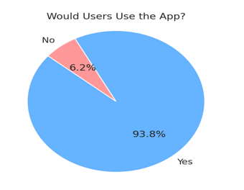

Figure 1: Users' interest in a Car diagnostic app

*This pie chart shows that 93.8% of survey respondents would find a mobile app useful for diagnosing dashboard warning lights and engine sounds.*

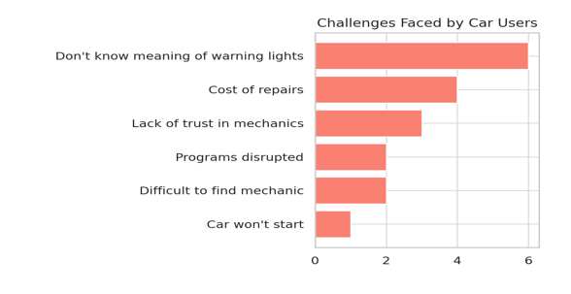

Figure 2: Common Challenges faced by Car owners

*Based on open-ended survey responses, this bar chart visualizes common challenges such as difficulty understanding warning lights, high repair costs, and lack of trust in mechanics.*

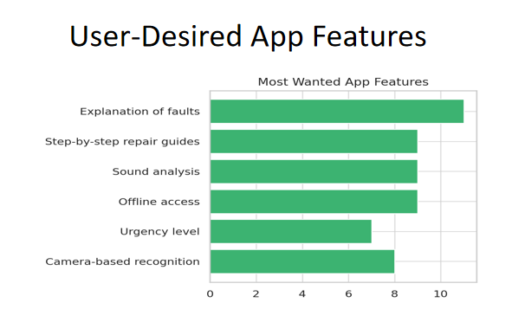

Figure 3: Most desired features in the proposed app

*This bar chart highlights the top features users want in the app, including explanations of faults, sound analysis, offline access, and repair guides.*

## Interview Findings

Participants

* Total interviews conducted: 9

**Key Themes from Interviews**

**1. Awareness and Experience with Dashboard Warning Lights**

* Most participants admitted to **not recognizing certain dashboard symbols**.
* A few said they had **ignored a warning light** because they didn't feel it was urgent or didn’t understand it.
* Some interviewees said warning lights create **anxiety or confusion**, especially when it’s unclear how serious the issue is.

**2. Current Actions Taken**

* Responses varied:
  + **Visiting a mechanic** was a common solution.
  + Others preferred to **consult friends or Google** the issue.
  + Some said they **ignore** lights they perceive as minor or non-urgent.

**3. Challenges Faced**

* **Lack of understanding** of warning lights was the most common challenge.
* **Fear of being overcharged** or misled by mechanics was raised.
* **Delays in fixing the issue due to cost or availability of help**.
* A few mentioned **breakdowns or being stranded** as a result of ignoring warning lights.

**4. Features on the Proposed App**

* Make the app simple and beginner-friendly.
* Allow saving of diagnosis history.
* Provide estimated repair costs or nearby mechanic recommendations.

To conclude,

Interviewees provided in-depth confirmation of survey insights: they face frequent uncertainty with warning lights, desire an easier way to understand car issues, and strongly support the idea of a smart diagnostic app. Their feedback gives clear guidance on which features to prioritize and how to improve usability.

# DATA CLEANING

After collecting responses from surveys and interviews, we performed a basic data cleaning process to ensure accuracy and relevance.

* Incomplete or duplicate survey entries were removed.
* Open-ended responses were grouped into themes (e.g., “don’t understand symbols,” “cost concerns”).
* Unrelated answers were filtered out to maintain data quality for analysis.

This step helped us work only with meaningful, clean data to reflect the real needs of our target users.

# USER RELUCTANCE ASSESSMENT

During our research, we identified a few users who expressed hesitation about using a car diagnostic app. Key concerns included:

* **Privacy**: Worry about the app recording or storing car-related data.
* **Accuracy:** Doubts about whether AI could give reliable results.
* **Overconfidence**: Some experienced drivers felt they didn’t need the app for warning lights—but still supported it for engine sound detection.

To address these concerns, we plan to implement:

* Offline functionality to reduce data privacy concerns
* Clear accuracy information and disclaimers in the app
* A simple, transparent interface with trusted sources for information

These insights are helping us make the app more accessible, trustworthy, and appealing to all user types.

# CONCLUSION

The requirement gathering process gave us valuable insights into the real challenges car owners face, particularly when it comes to interpreting dashboard warning lights and understanding engine issues. Our surveys, interviews, observations, and reverse engineering revealed a clear demand for a user-friendly, trustworthy, and smart diagnostic tool.

We discovered that while experienced drivers are often familiar with dashboard indicators, they still see value in the app's sound analysis features. Newer drivers showed interest in all core functionalities, confirming a broad user base for our proposed solution.

By combining this feedback with a careful understanding of user concerns, we are now well-equipped to move into the requirement analysis and system design phase. This will help ensure the final product not only meets user needs but does so in a secure, efficient, and accessible way.

Our goal remains to build an app that empowers users to take control of their vehicle’s health saving time, money, and reducing unnecessary stress in the process.